**Folders Created**

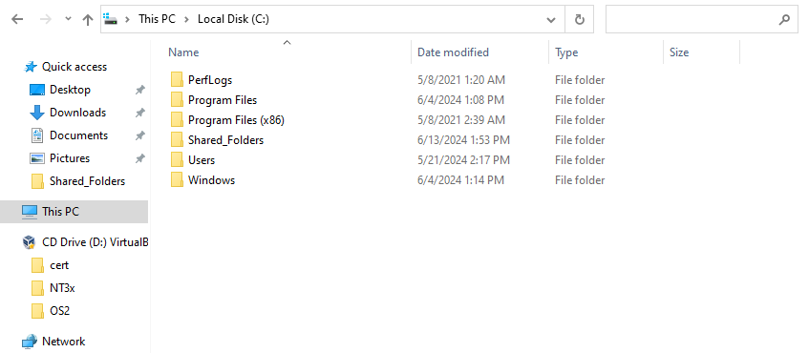

This screenshot shows the Shared_Folders folder created inside the C Drive.

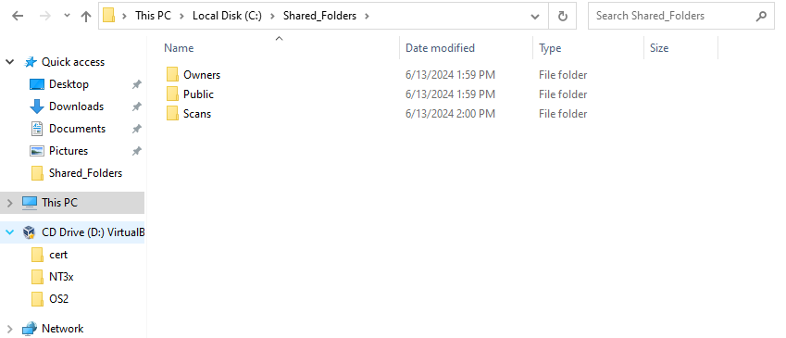

This screenshot shows the three folders to be shared placed inside the Shared_Folders folder.

**Folders Shared**

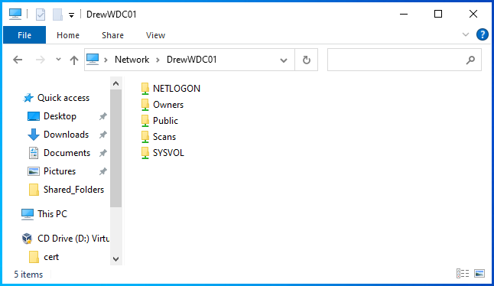

This screenshot shows that the folders are shared out over the network, without sharing their parent folder.

**Public User**

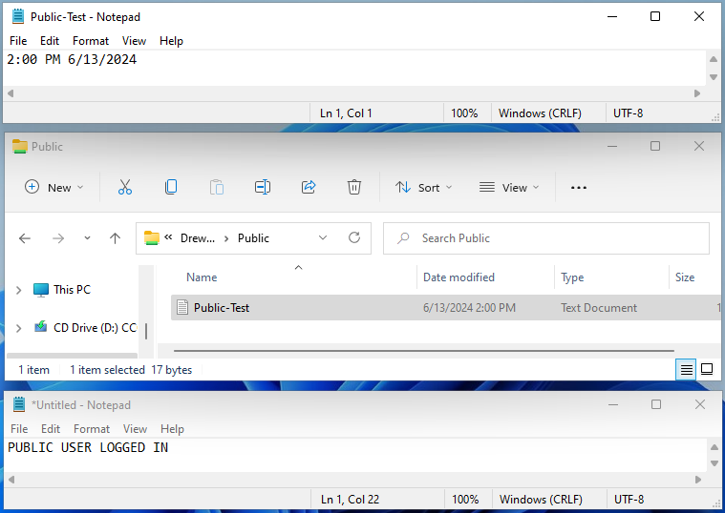

These screenshots show the public user attempting to access the three shared folders. They are able to access the file within the *Public* folder, but they are unable to access the *Scans* and *Owners* folders.

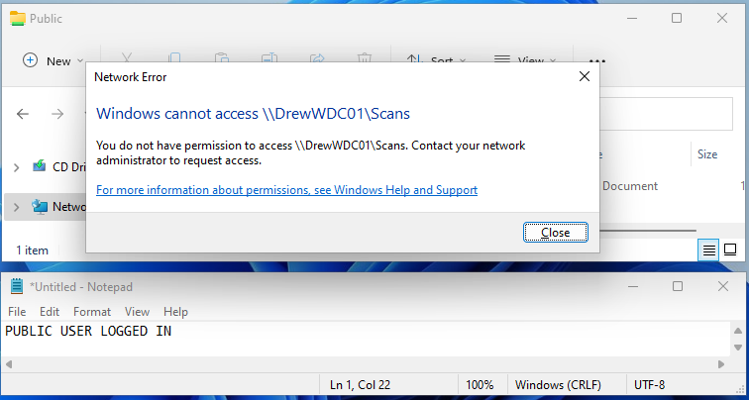

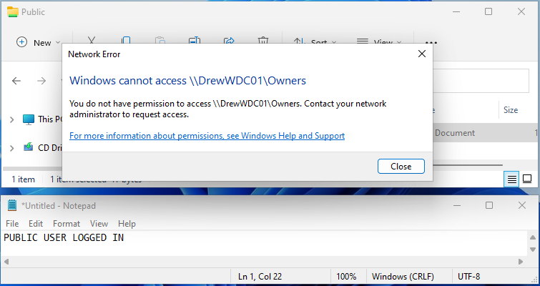

**Scanner User**

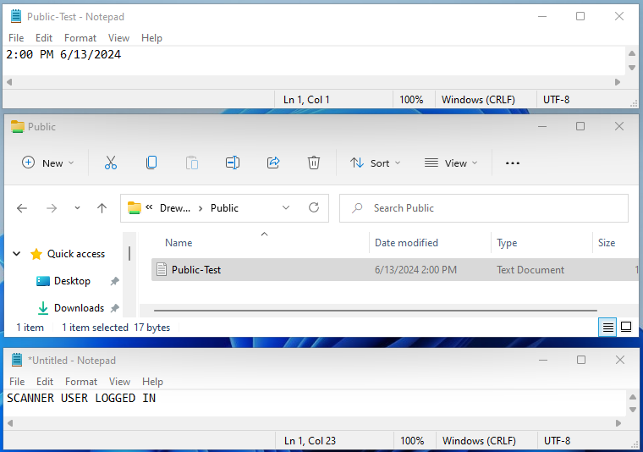

These screenshots show the scanner user attempting to access the three shared folders. They are able to access the files within the *Public* and *Scans* folders, but they are unable to access the *Owners* folder.

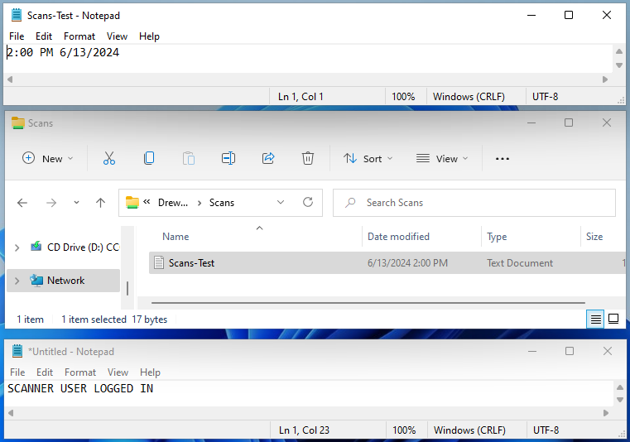

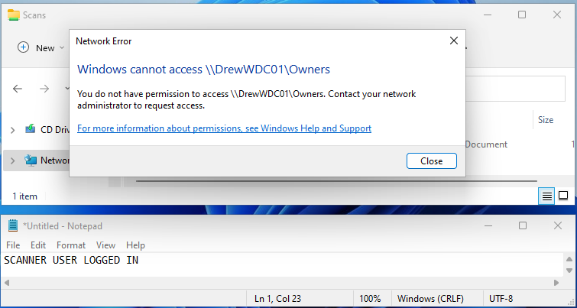

**Partner User**

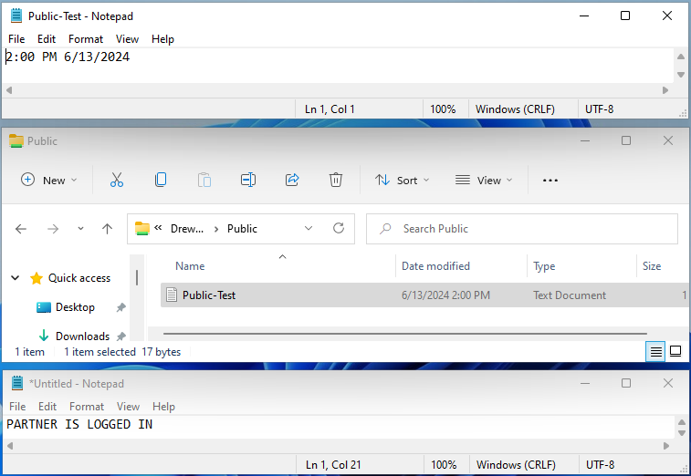

These screenshots show the partner user attempting to access the three shared folders. They are able to access the files in all three folders.

